All entities that have filed or appeared on an E-Rate Form 471 have an EPC Portal Account.

- School districts have an EPC account that lists their member schools.

- Independent schools or schools that do not belong to a school district also have an EPC account. Schools that are the only school in their school district may be listed in EPC as the school rather than at the school district level.

- Libraries have an EPC account.

To set up the account administrator for your billed entity's EPC account, you will need to email a written request to USAC.

If sending the request from the email address of the account administrator:
The email address of the account administrator must include their name and the entity’s email domain
e.g. johndoe@schooldistrict.org

If sending the request from another email account:
You must make the request on entity letterhead and include the signature of the authorized person who should be set up as the account administrator

Steps to Establish an EPC Account Administrator

- Create a new email to the recipient SLDPR@GDIT.com

- Copy the text below either into the body of the email message or onto entity letterhead

Please establish the EPC account administrator for [BILLED ENTITY NUMBER] - [BILLED ENTITY NAME] as indicated below.

1. Name of Account Administrator: [NAME]
2. Job Title: [TITLE]
3. Mailing Address: [ADDRESS], [CITY], [STATE], [ZIP]
4. Phone Number: [PHONE]
5. Email Address: [EMAIL]

(Note that since the EPC user account will act as an authorized signature,
USAC requires the email address to contain the account administrator’s name. It cannot be a generic email address such as erate@schoolname.org.)

- Fill in the [ ] fields with the appropriate information for the account administrator

- If you are using letterhead, obtain the signature of the authorized person, scan and save the signed letter to your computer, and attach the document to the email message

- Send the email to SLDPR@GDIT.com
If you prefer, you can FAX it instead to 1-888-276-8736

- The account administrator will receive an email invitation from EPC.Application.Administrator@usac.org with the subject “USAC EPC-Account Creation”

- Follow the steps below to set the first password:

STEP ① - Click on the link in the invitation email or navigate to the URL for the EPC Portal at https://portal.usac.org/suite/
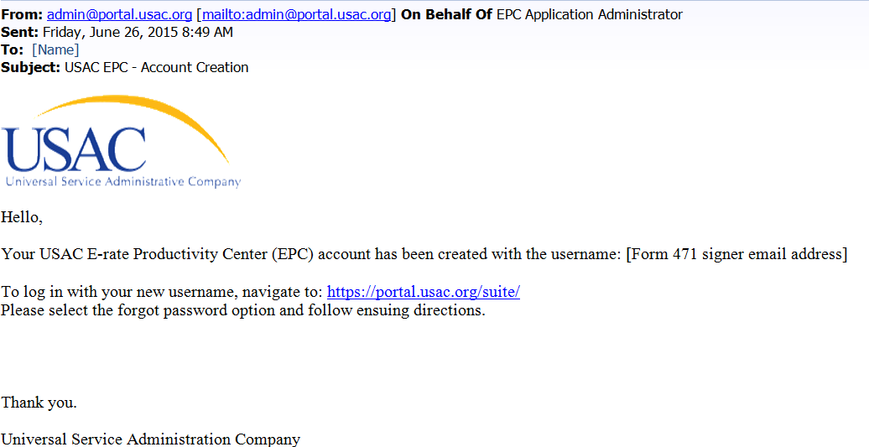
Click on the link to the EPC Portal

STEP ② - An informational screen will display

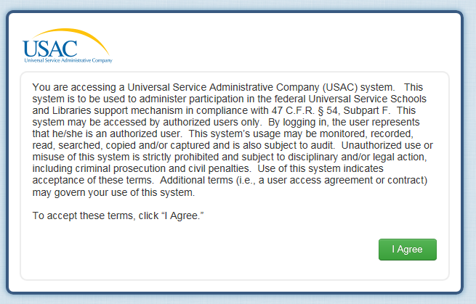
Click on the “I Agree” button to proceed

STEP ③ - The login screen will display

A Enter the username (the account administrator’s full  email address)  B Click on the “Forgot Password” link | 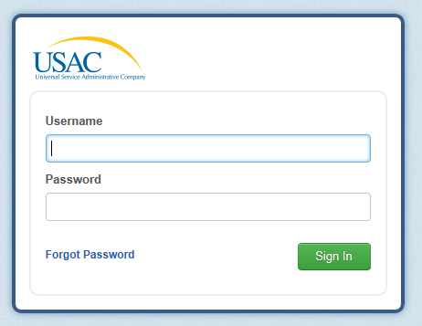

STEP ④ - The Request Password Reset screen will display

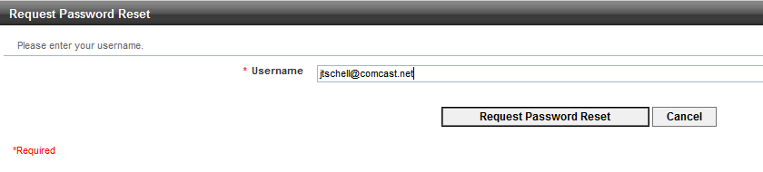
A Enter the username
B Click on the “Request Password Reset” button

STEP ⑤ - The EPC system will send an email to the account administrator with a temporary link
(Note: the link is only active for 15 minutes)
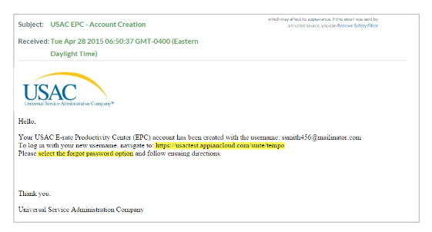
Click on the link in the email or navigate to the URL in a browser window

STEP ⑥ - The browser will load the Enter New Password screen

A Enter the username | 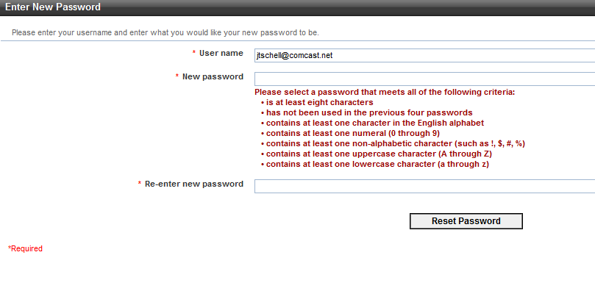 | B Enter the desired password twice:  once in the “New password” text box  and once in the  “Re-enter new password” text box
 | C Click on the “Reset Password” button

STEP ⑦ - The system will display a screen stating that your password has been reset and that you may now log in to EPC
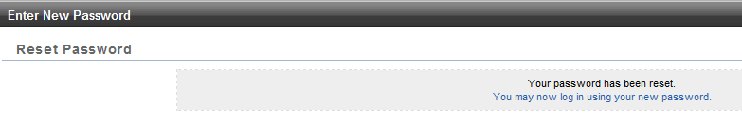
Click on the link to log in using the new password

STEP ⑧ - The login screen will display
A Enter the username

C Click on the “Sign In” button

B Enter the new password

STEP ⑨ - The news page for the EPC account will display with a welcome message
Click on the link in the message

STEP ⑩ - A task to complete the Terms and Conditions will display

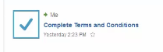
Click on the task

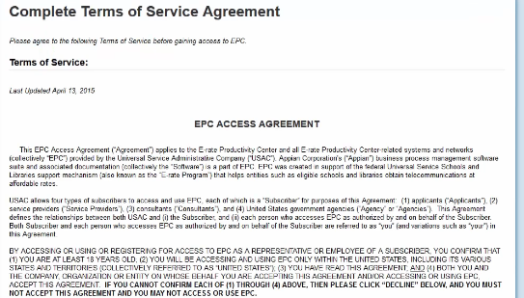
STEP ⑪ - The terms and conditions will display

A Read the terms and conditions listed

B Scroll to the bottom of the page

C Click on the “Accept” button

